Jackson Warren

Jeremy Bergen

CSCI 370

9/17/21

Week 3 Lab

1. For file structure here, each class has a folder based on topic (Security, Programming, and Networking). Then, by specific class section (SEC101 and SEC202). Logic was organization based on little clutter on the main screen, then narrowing based off topic to get to the right folders.

* Networks
  + NET101
    - Assignments
    - FacultyNotes
    - LectureNotes
  + NET202
    - Assignments
    - FacultyNotes
    - LectureNotes
* Security
  + SEC101
    - Assignments
    - FacultyNotes
    - LectureNotes
  + SEC202
    - Assignments
    - FacultyNotes
    - LectureNotes
* Programming
  + PRO101
    - Assignments
    - FacultyNotes
    - LectureNotes
  + PRO202
    - Assignments
    - FacultyNotes
    - LectureNotes

11 (1.1):

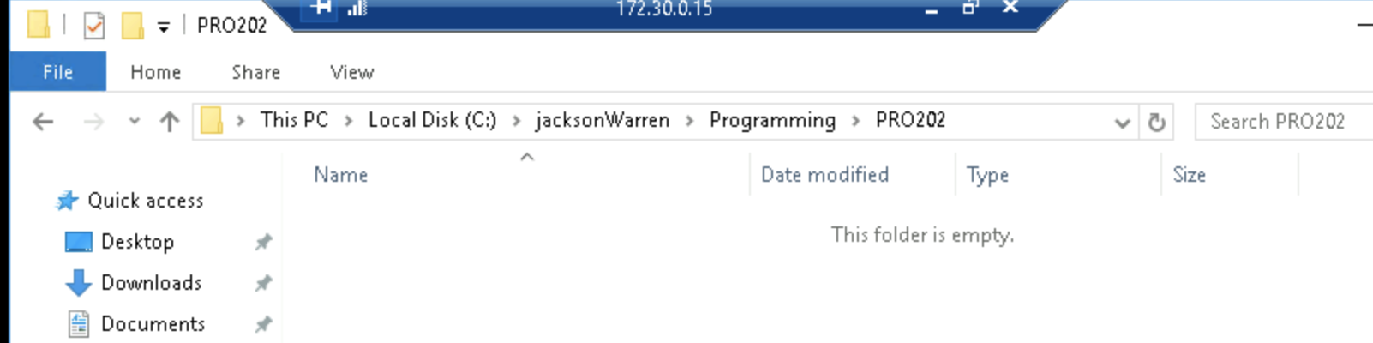

14 (1.2): 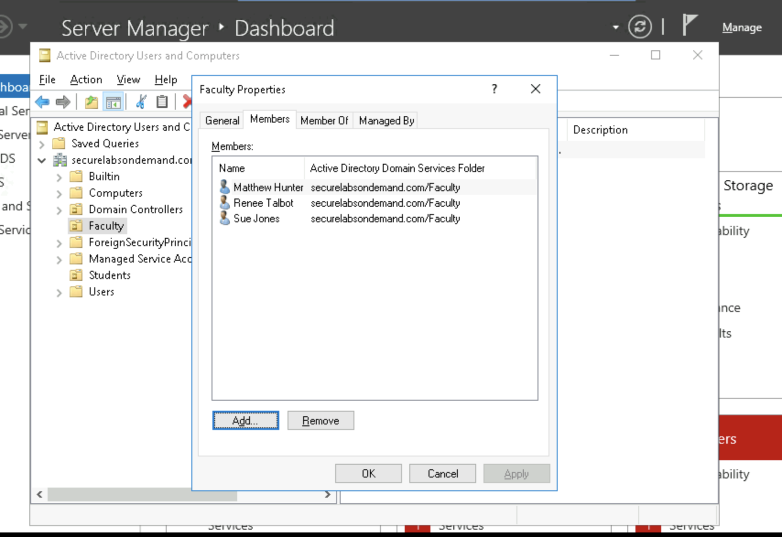

16 (1.3): 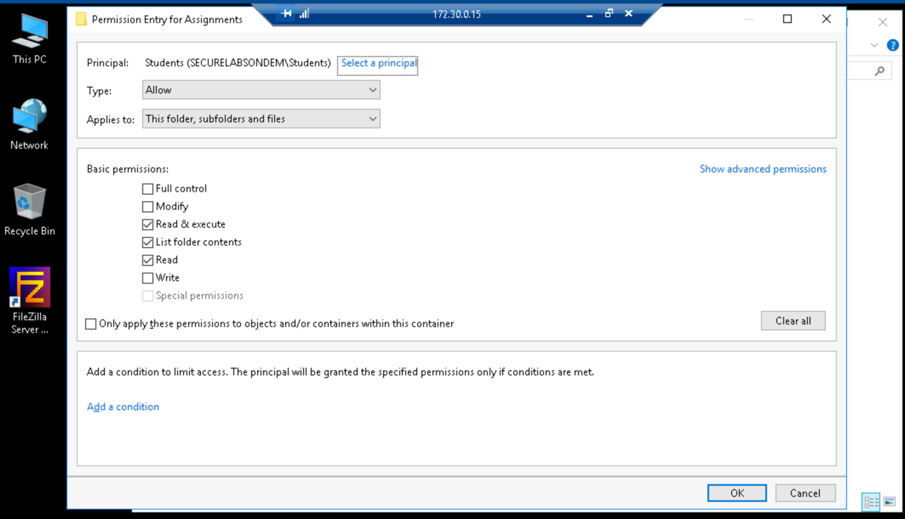

22 (1.3):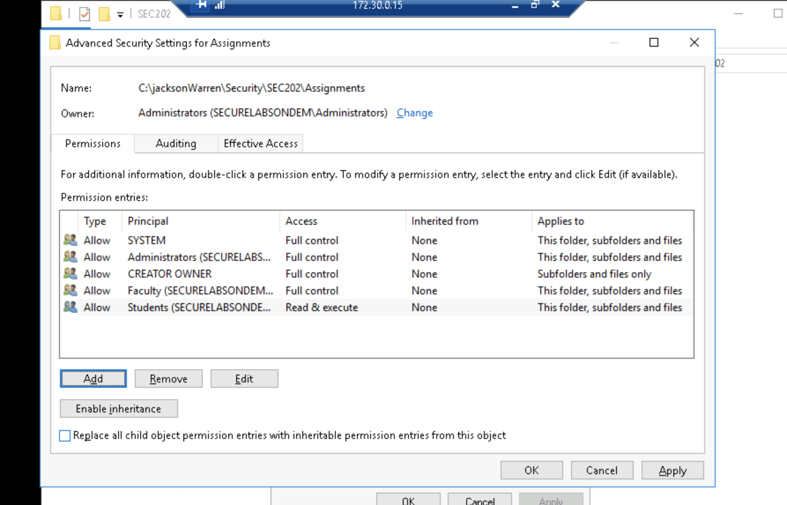

10 (2.1):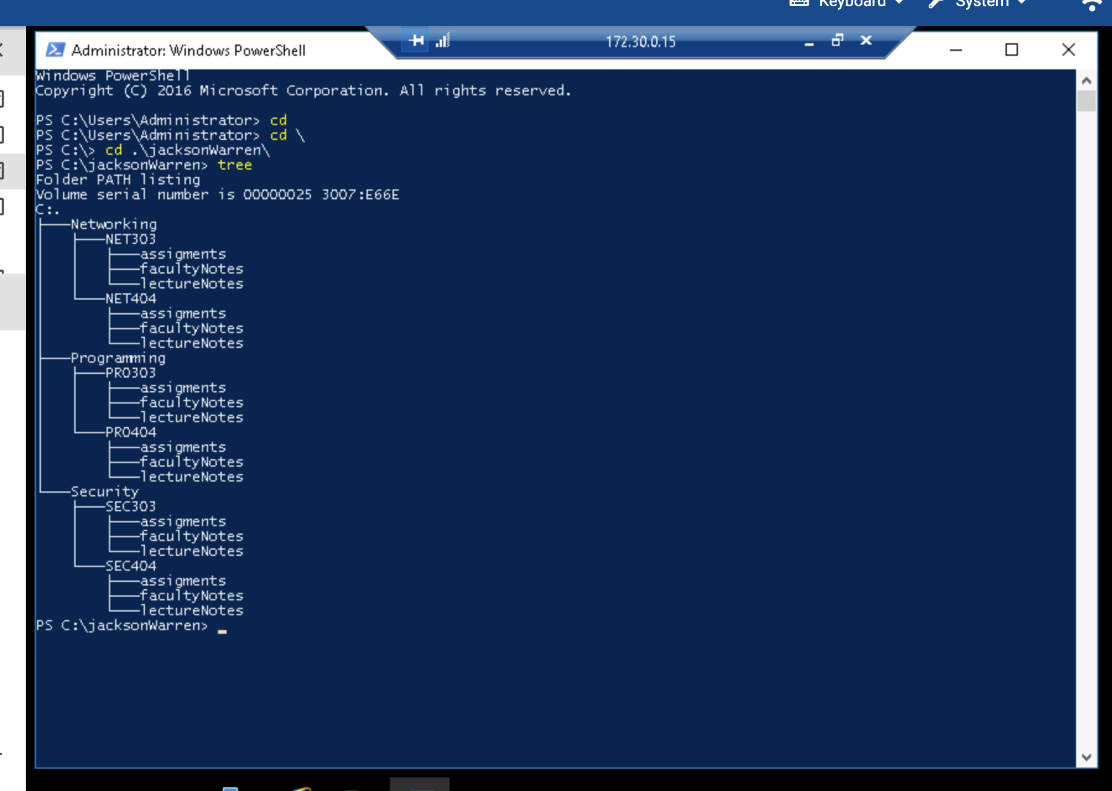

6 (2.2):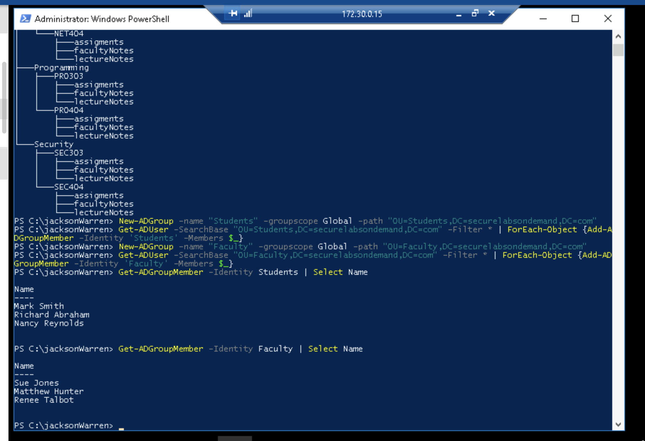

7 (2.3): 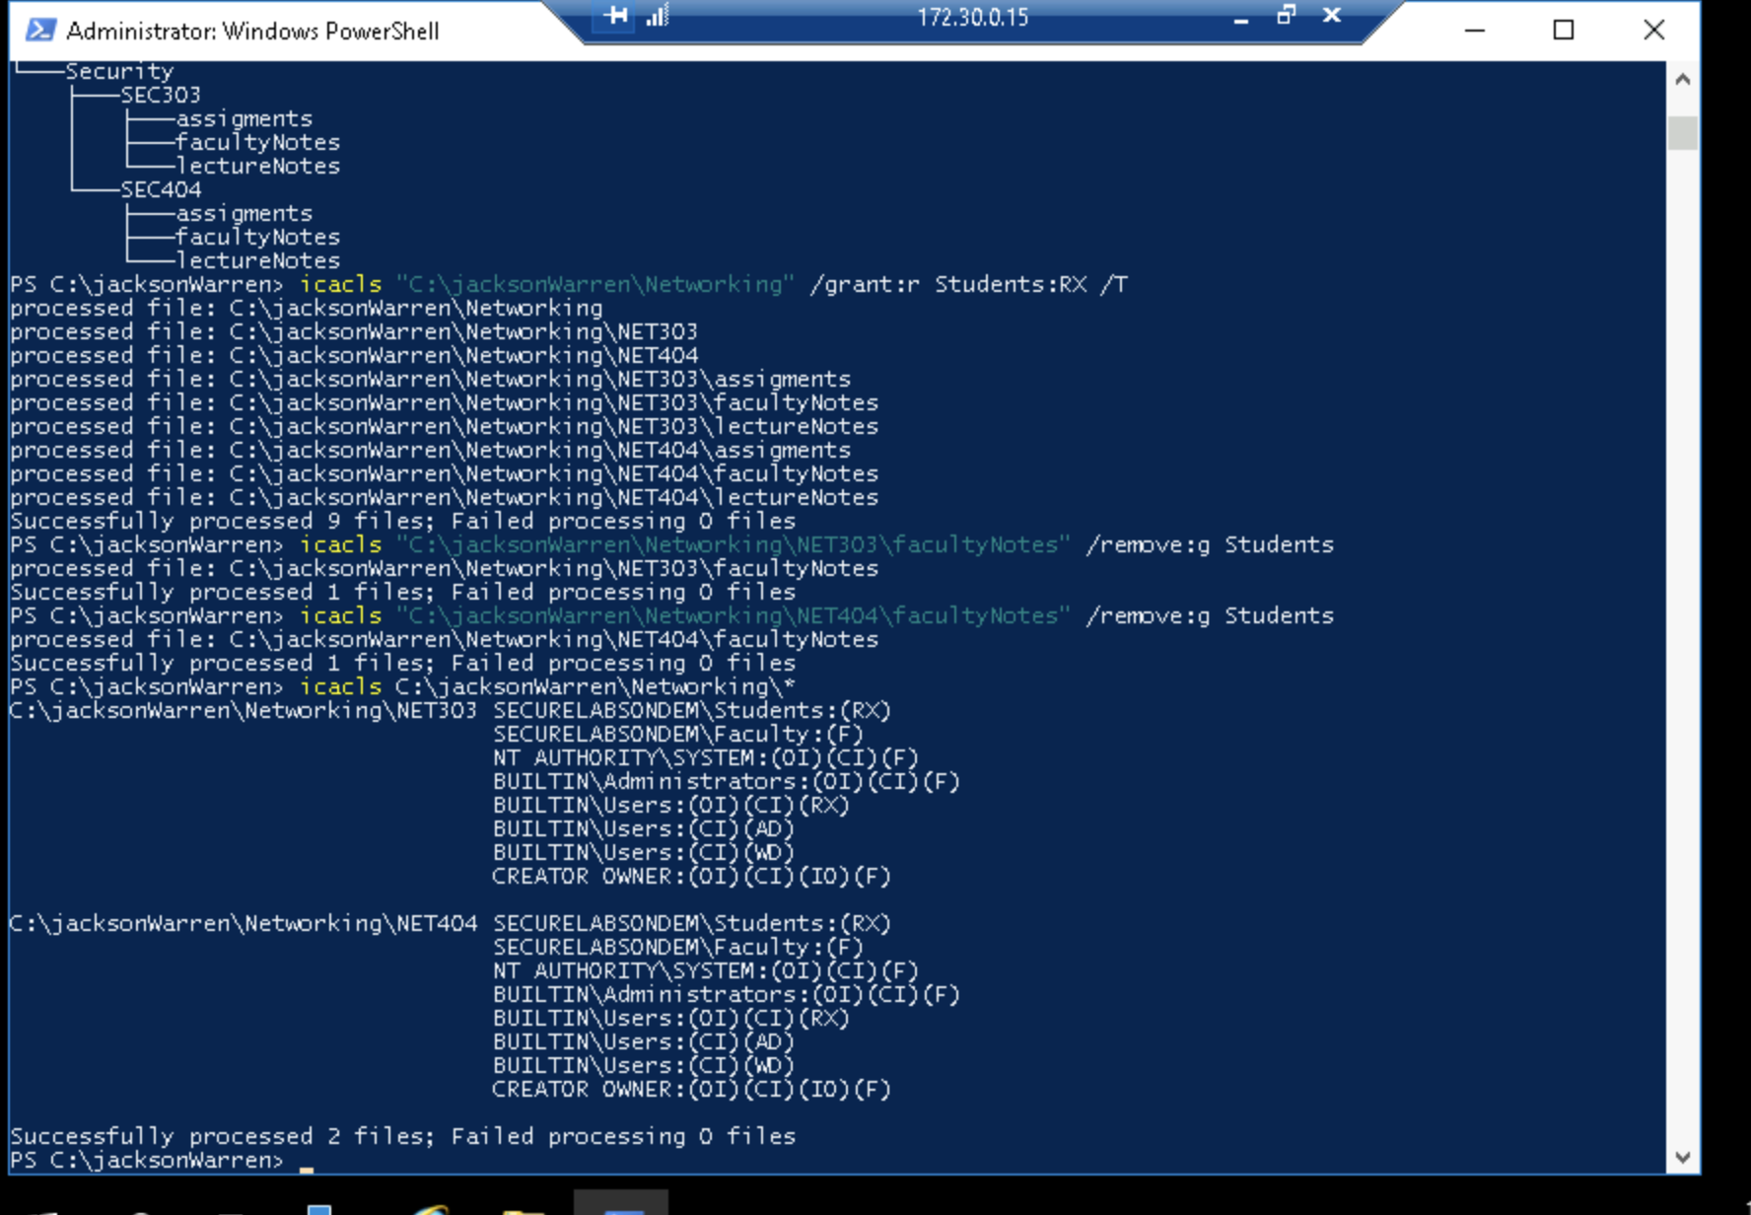

10 (2.3): 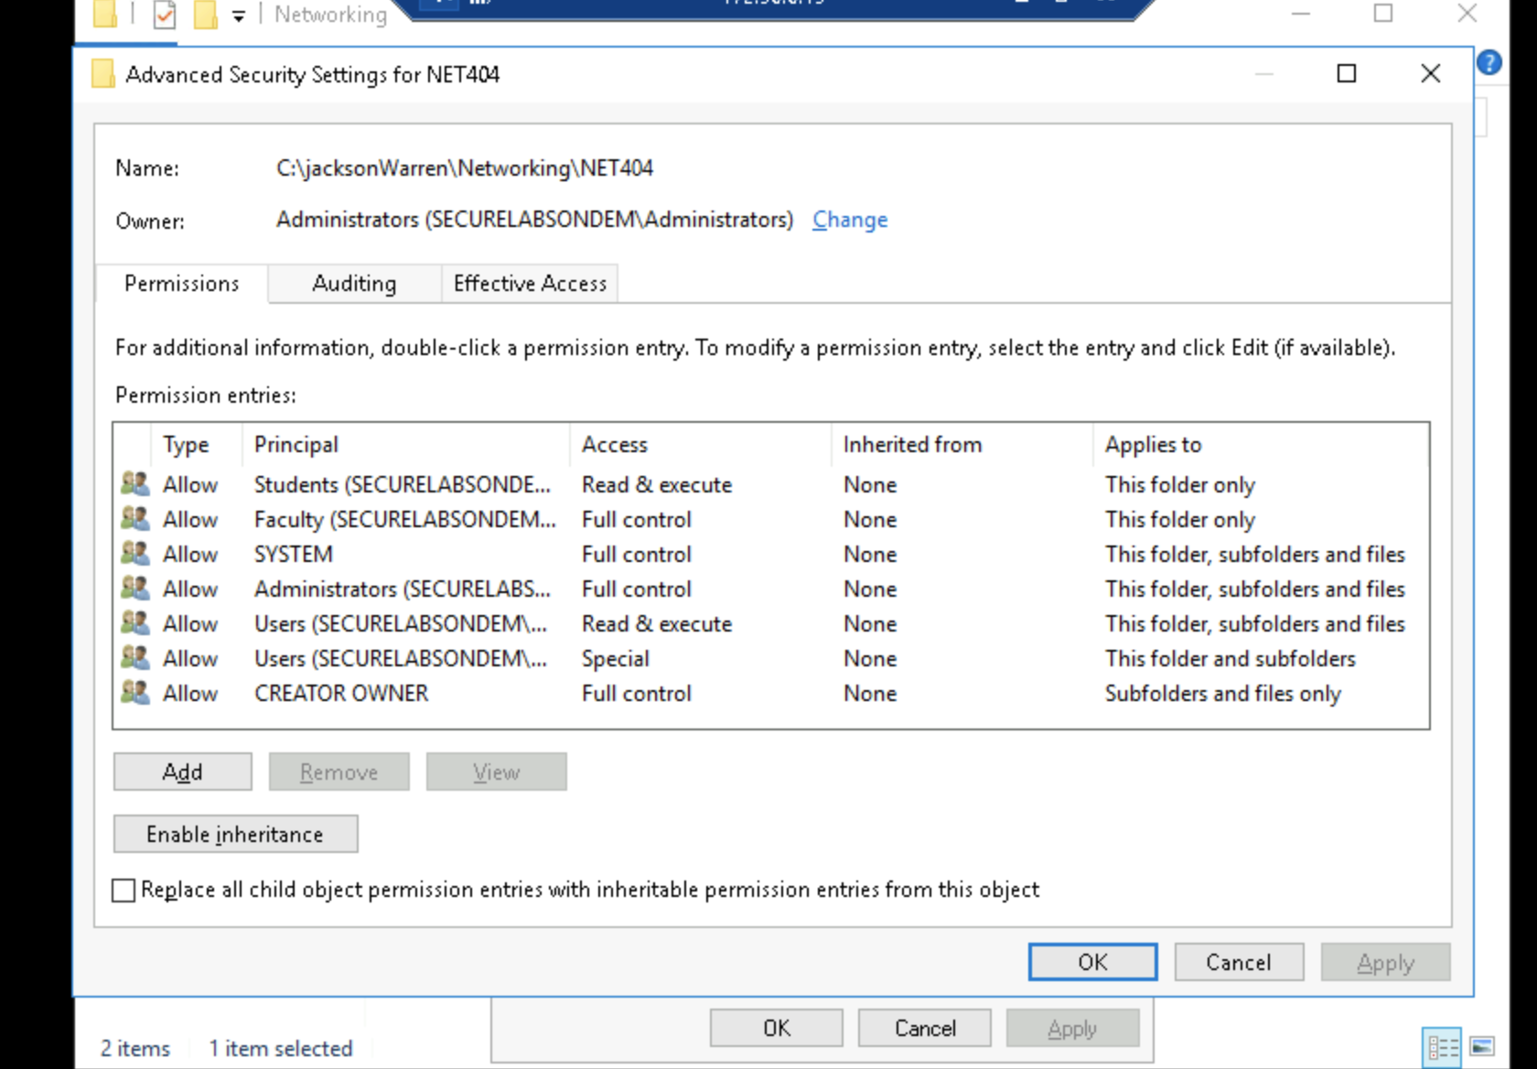

3.1:

* Networks (Faculty: F; Students: RX)
  + NET101 (Faculty: F; Students: RX)
    - Assignments (Faculty: F; Students: RX)
    - FacultyNotes (Faculty: F; Students: None)
    - LectureNotes (Faculty: F; Students: RX)
  + NET202 (Faculty: F; Students: RX)
    - Assignments (Faculty: F; Students: RX)
    - FacultyNotes (Faculty: F; Students: None)
    - LectureNotes (Faculty: F; Students: RX)
* Security (Faculty: F; Students: RX)
  + SEC101 (Faculty: F; Students: RX)
    - Assignments (Faculty: F; Students: RX)
    - FacultyNotes (Faculty: F; Students: None)
    - LectureNotes (Faculty: F; Students: RX)
  + SEC202 (Faculty: F; Students: RX)
    - Assignments (Faculty: F; Students: RX)
    - FacultyNotes (Faculty: F; Students: None)
    - LectureNotes (Faculty: F; Students: RX)
* Programming (Faculty: F; Students: RX)
  + PRO101 (Faculty: F; Students: RX)
    - Assignments (Faculty: F; Students: RX)
    - FacultyNotes (Faculty: F; Students: None)
    - LectureNotes (Faculty: F; Students: RX)
  + PRO202 (Faculty: F; Students: RX)
    - Assignments (Faculty: F; Students: RX)
    - FacultyNotes (Faculty: F; Students: None)
    - LectureNotes (Faculty: F; Students: RX)

When comparing the two different structures, both had the same results. The Get commands did exactly this to the files, adding groups and their permissions as stated in the structure. The inheritance carries from the parent folder (NET303 for example) to its children folders (assignments, facultyNotes, and lectureNotes). Then, we remove some access to those facultyNotes folders so they resemble the desired structure.

3.2: 

3.3:

1. 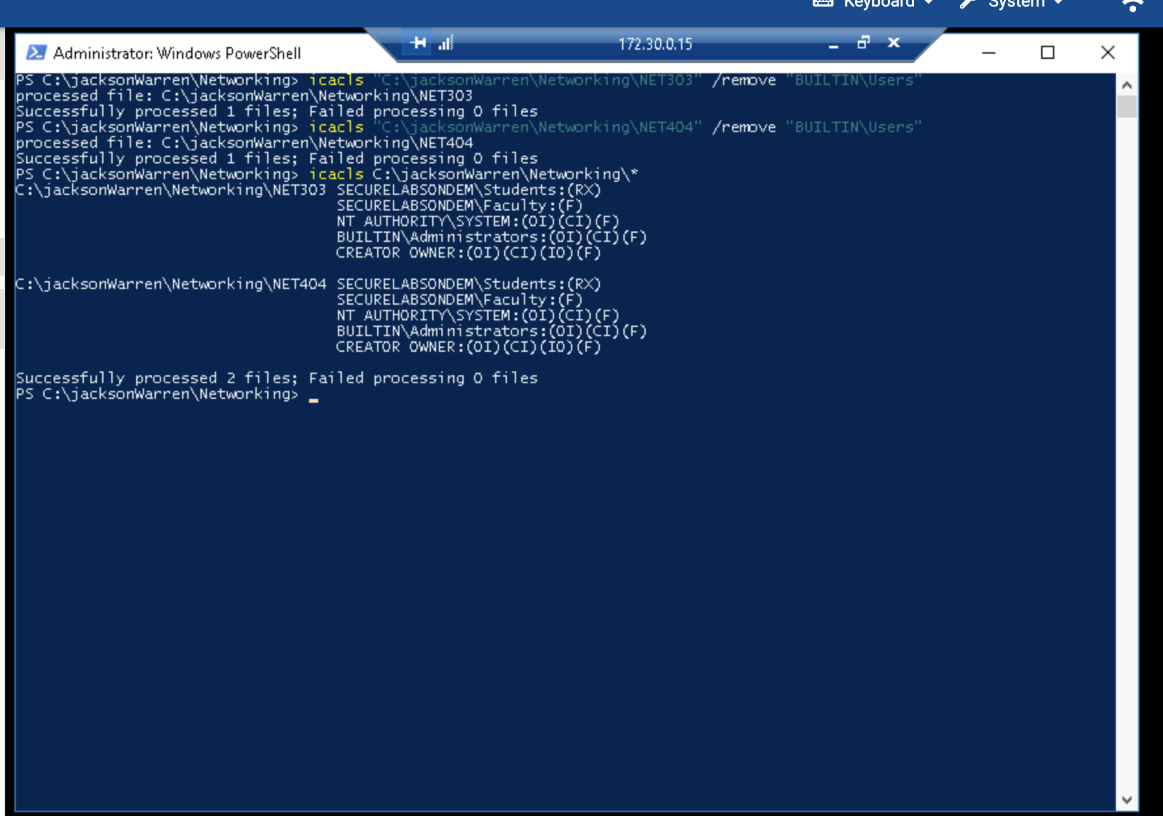

2.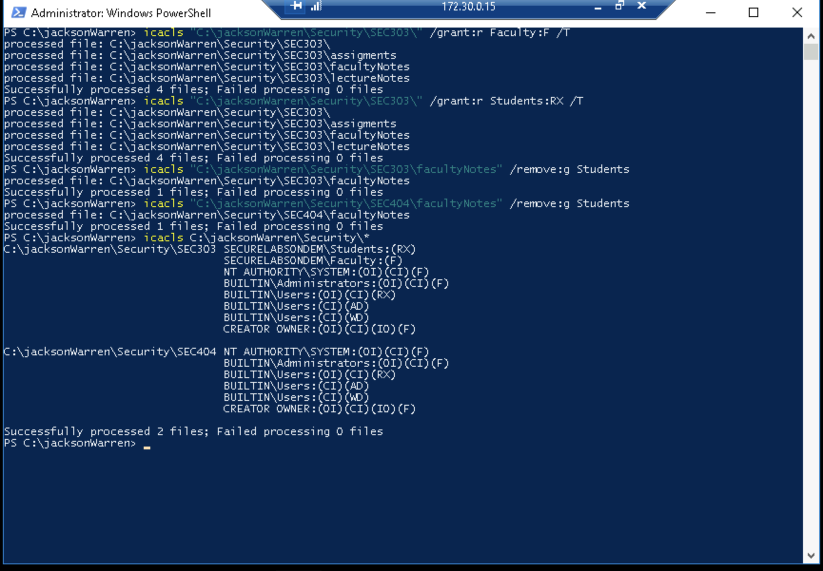

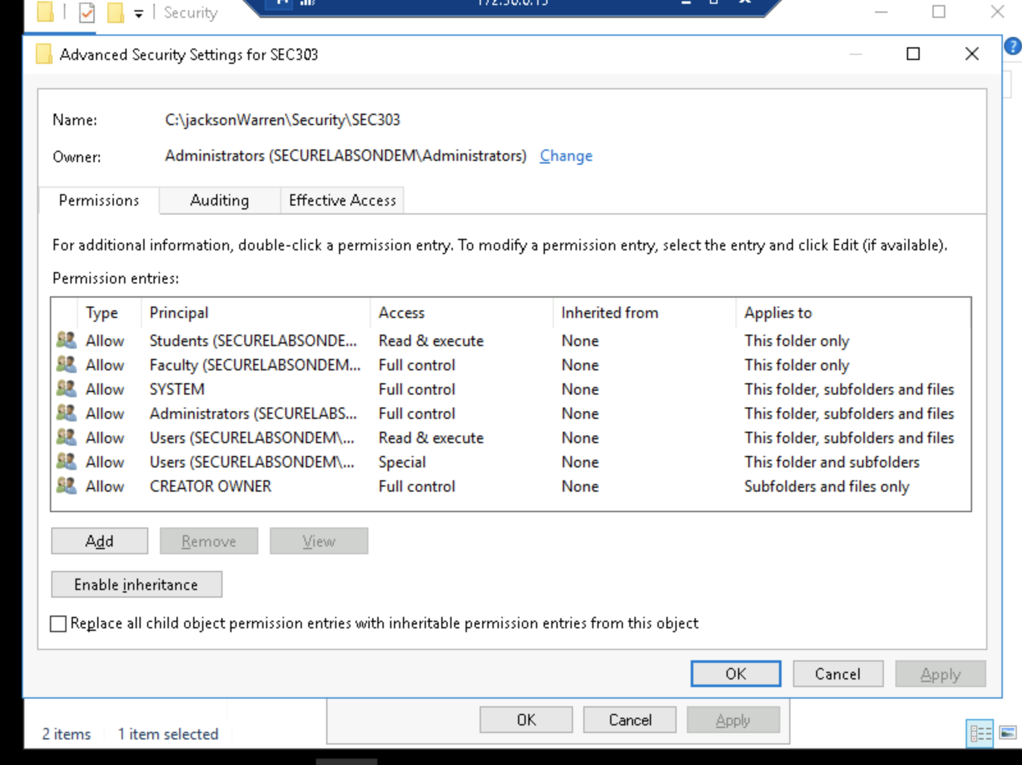

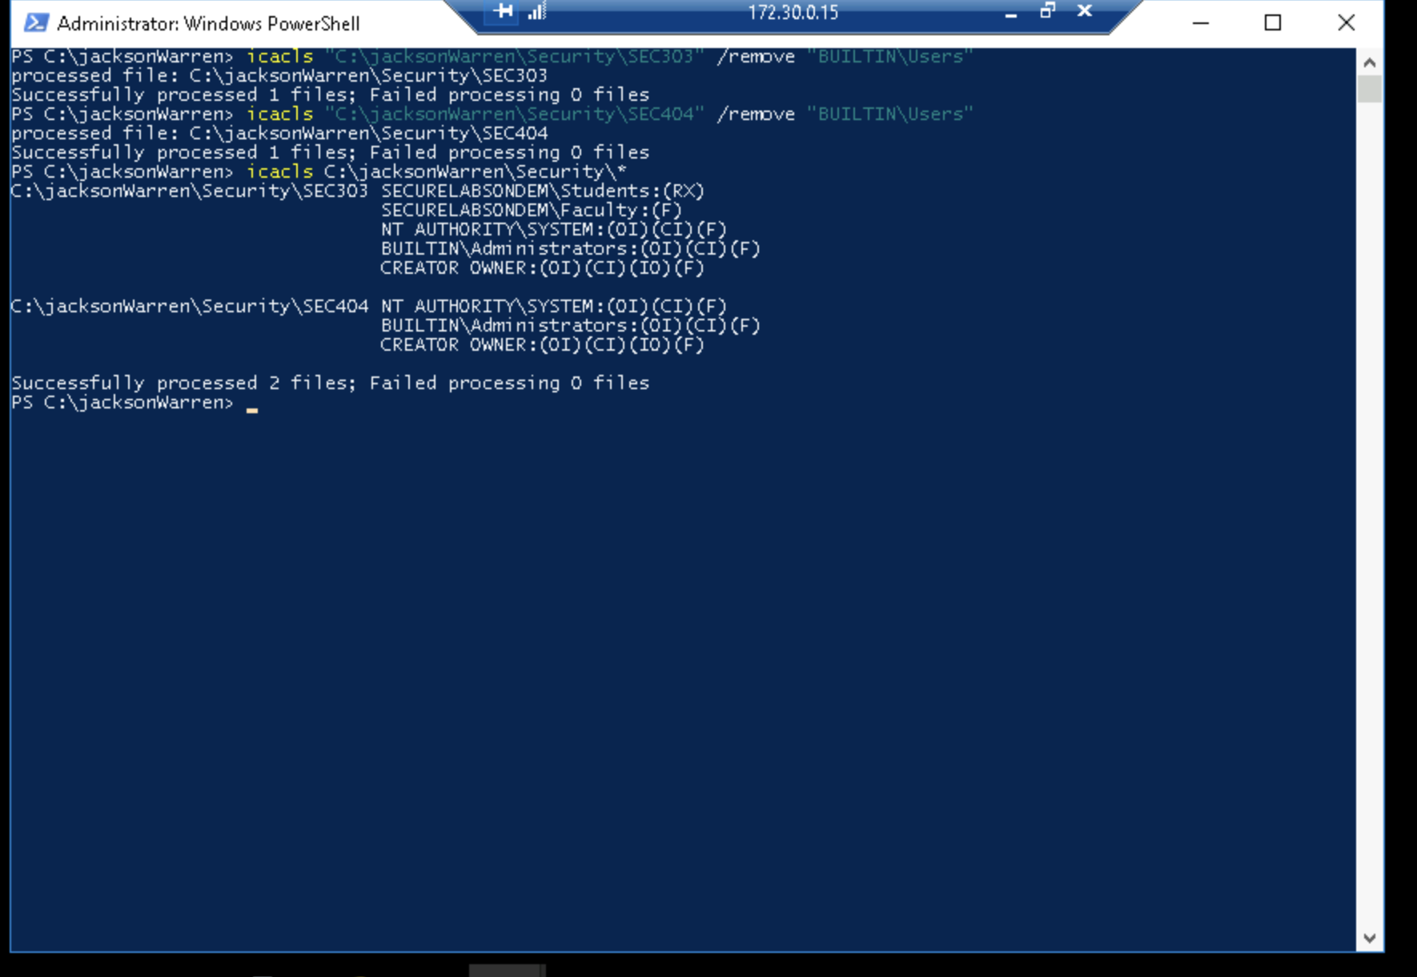

Hopefully…I hit everything. Wow. This lab was a journey for me.